***Winter Internship Project Report***

***on***

***Road Asset Detection***

|  |
| --- |
| cid:image001.jpg@01D1FC90.7D09CEE0 |
| **LeadingIndia.ai** |

|  |  |
| --- | --- |
| Submitted To: | Submitted By: Team Number – 23 |
| Dr. Sridhar Swaminathan | Chandra Mohan, Ramco Institute of Technology |
| Swapnil Panwala | Akanksha, Bennett University |
|  | Nandavardhan, Bennett University |
|  | Jagadheep Kanna, Ramco Institute of Technology |



**Introduction related to the domain area of the project**

Our project is an extended work on the blooming Computer Vision on localization of relevant objects. We implement a real-time system capable of accounting for different road assets like traffic signs,potholes,lanes,zebra lines and vehicles . We have used the YOLO model for this purpose.We used this model as they have superior localization and classification in addition to easier modification of layers,via transfer learning.We further seek to implement a fully functional real time system on Indian Roads.

**Problem Statement/ Abstract of the project and objectives**

In the existing world, all the geographical areas, continents, countries states, cities and villages etc. are connected by several means of transportation such as air, trains, metros and roads. The road transportation is one of the busiest and cheapest way to connect one source point to its destination point.These days the road networks have become too large in India the road network has been to be 5.6 million kilometres approx. as on 31 March 2016,the second largest road network in the world. To maintain all the roads in a good condition is a very difficult job. Failure of the road or surface due to traffic loading and weather conditions causes potholes.Locating damages to roads and bringing them to the official notice is a time taking procedure.No,we are automating this by detecting the damages to roads i.e.potholes with localization.We are also focusing on maintaining a track of all the sign boards present while also keeping a track of the different vehicles that traverse on a particular road.

**Why and how the project was chosen-**

The main inspiration behind the project is reduce the difficulties faced by the road contractors who face difficulties in identifying the damages to a road as well as it helps in maintaining a record of the different types of vehicles traversing on a road which helps in making the road durable enough to withstand those traffic loads.The module that deals with traffic sign detection and recognition deals helps in keeping track of all the signs present on a road. Also the entire project including the detection of lane lines as well as vehicles, apart from detection of road assets, can be further implemented in self driving cars.

**Literature Survey/background search/study of similar projects**

We have gone through similar projects in each module (i.e detection of potholes, traffic signs,traffic lights, zebra crossing, lane lines and vehicles).After going through various links, implementing one, getting stuck in between and figuring out other ways as to how to get rid of the errors, we finally went with Image Processing using openCV for the detection of lane lines and pedestrians. For the detection of vehicles, traffic lights and traffic signs we used YOLOv2 (a state of the art object detection system ) to train our model.Potholes were detected through both YOLOv2 and image processing techniques.

**Project Design Diagram/use case diagram/class diagram/Flow Diagram/Block diagram/Flow charts etc.**

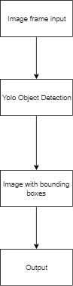

**Functionality of the project/snap shots**

**Lane lines:**

**Canny Edging, Hough Transform**

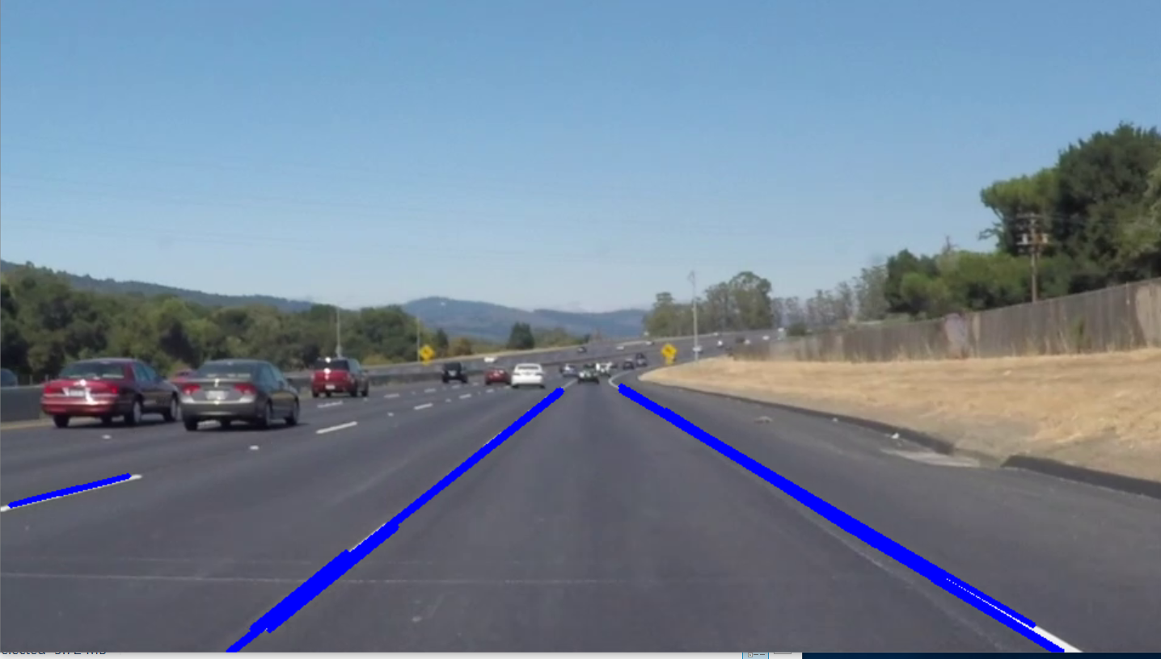

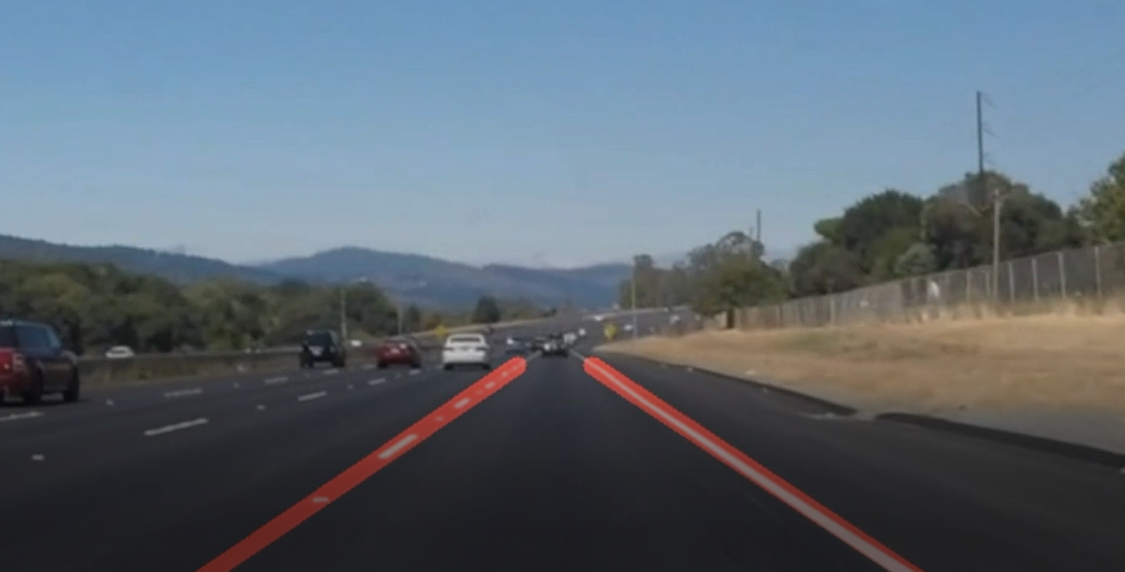

**Pedestrians:**

**OpenCV , Haar Cascading**

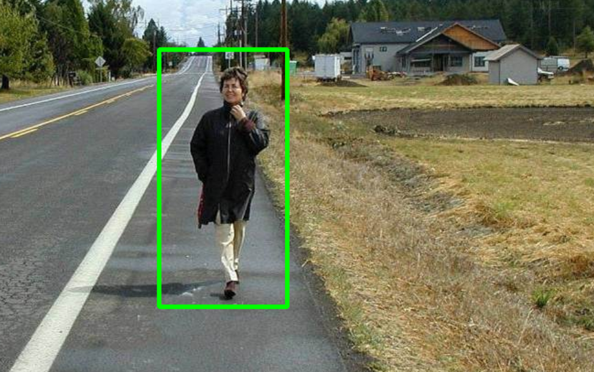

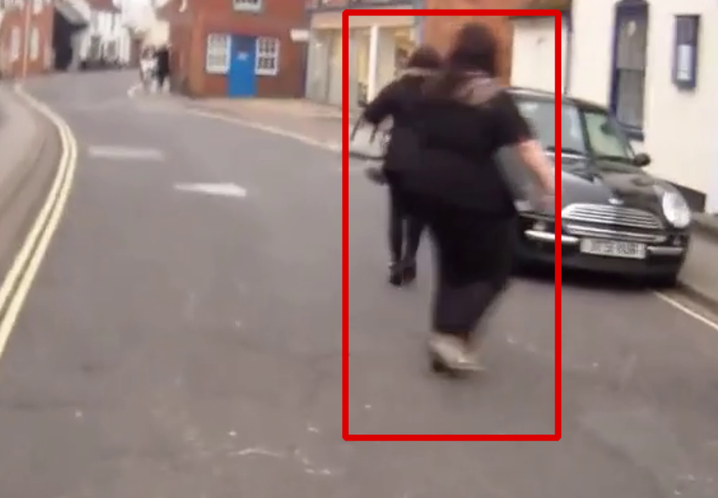

**Vehicles:**

**Pascal VOC**

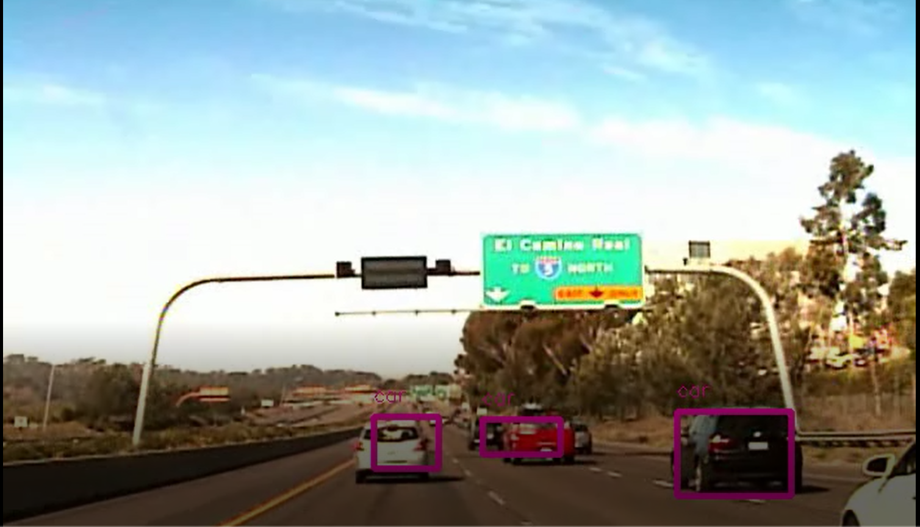

**Potholes :**

**Different Method Implementations using Image Processing methods:**

**Gaussian Blur, Dilation,Simple Canny**

All Contours

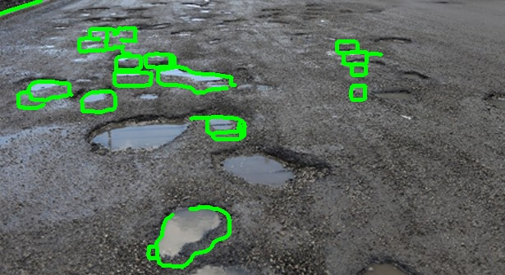

Circular Contours

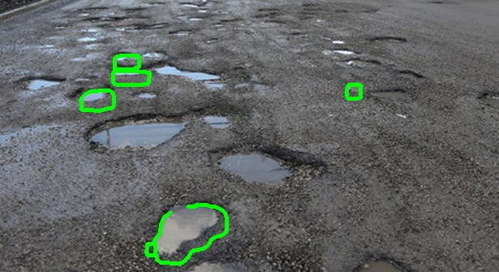

**Gaussian Blur,Dilation,Threshold,Auto Canny**

All Contours

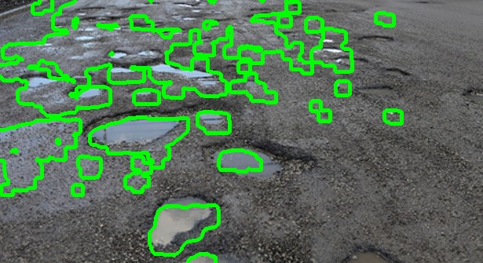

Circular Contours

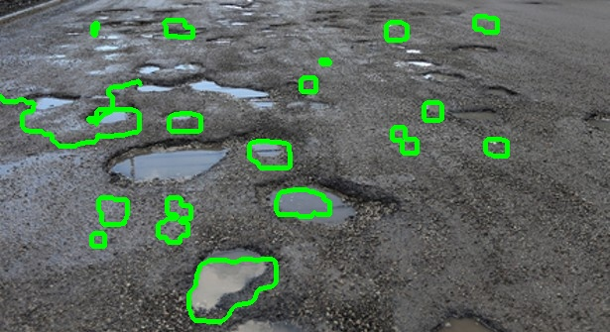

**Gaussian Blur,Dilation, Auto Canny**

All Contours

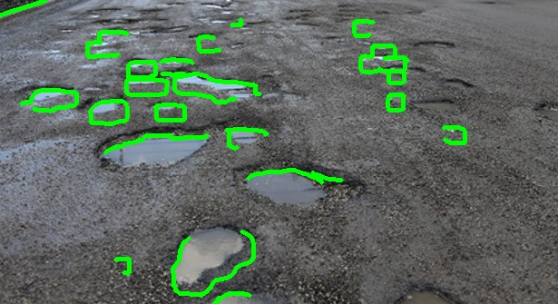

Circular Contours

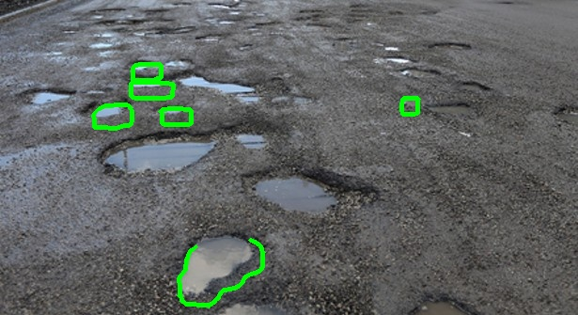

**Gaussian Blur,Dilation,Threshold, Simple Canny**

All Contours



Circular Contours



**Traffic Signs:**

Original Image

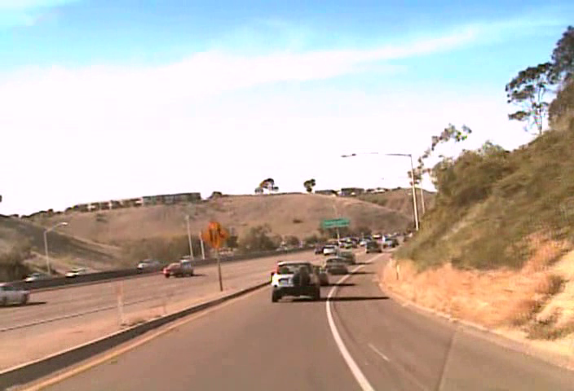

Detected Image:

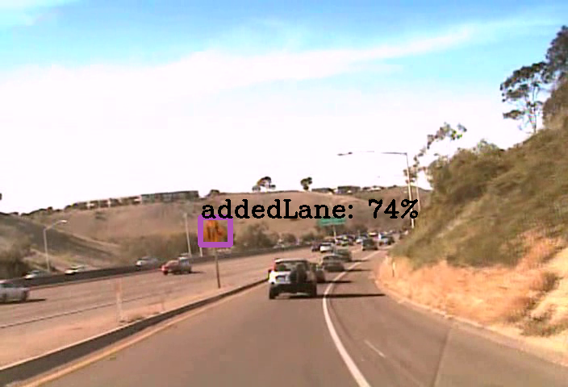

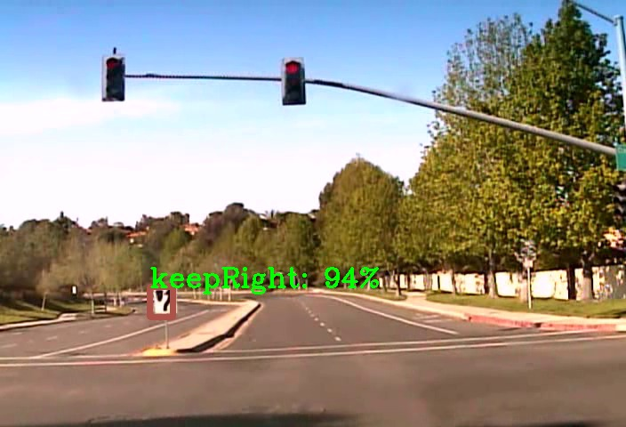

**Failed examples**

Only one pedestrian being detected:

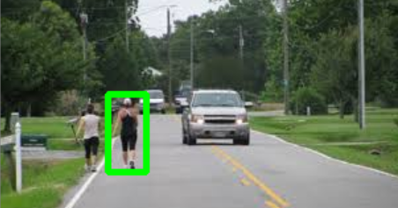

Crash barrier being detected as a lane line:

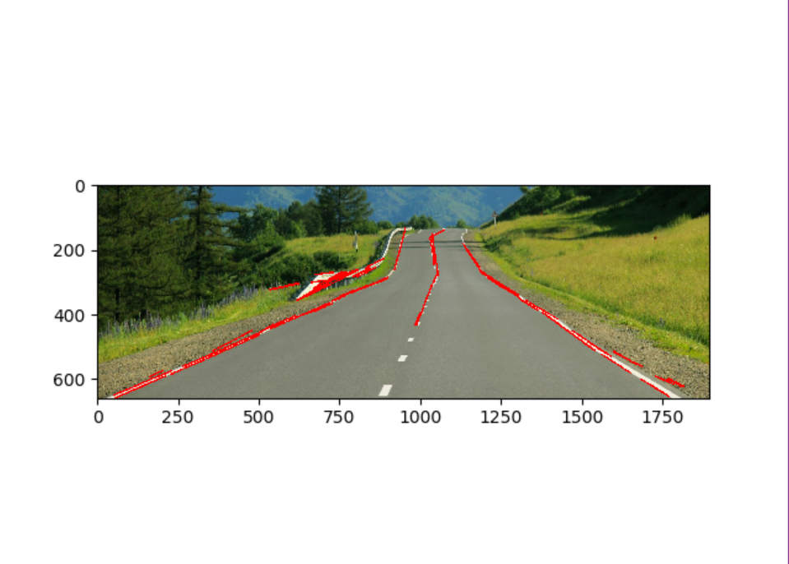

**Implementation details/demonstration details**

To implement this project one needs to have the following dependencies installed :

* Darkflow
* Numpy
* Opencv Version:3.2.0.6

Once you have the above dependencies and you have the required config and corresponding weight files installed you can run the project by implementing the predict.py file mentioning the video path.

**Information regarding training**

|  |  |
| --- | --- |
| **Epochs** | 120 |
| **Dataset size** | Potholes; 630  Pascal VOC: 2029  LISA: 6618 |
| **Accuracy** | 84  88  87 |

**Project Development Time Schedule**

We started the work on 21st of December. Following is the schedule we followed:

21st-25th : Collection of Datasets for the road assets

26th-27th : Detection of potholes

28th-31st: Detection of lane lines and pedestrians on images

2nd Jan : Implementing on a video

3rd-4th : Research on bird-eye view

6th-9th : Collection of dataset and work on vehicle detection

10th : Project evaluation

**Learnings and reflections from the project**

It was really a great learning experience working for this project. Our team members were working on AI for first time, so it was little hard for us but we were successful in learning about AI, knowing it’s practical applications and working on it in a project-based manner. We were also able to learn about its possibilities in future. Coming from different Universities, team members were also able to learn about each other and the Institutions they belong to. Our team was also able to know about the fast developing fields like edge computing. Team work was our key to successfully complete the project.

**Conclusion**

We could successfully build a model that pays off our objectives. Although there were few cases where the model wasn’t accurate in detecting, yet it could correctly detect for most of the images and videos we tested it upon. The model could be further trained to improve the accuracy and efficiency. As mentioned earlier, it could be used by government firms for the proper maintenance of roads and its assets and also take timely measures to prevent further damages, if they find any. Also, by making it efficient and adding few more parameters, it could be implemented in self driving cars and various other driving assistance applications in the future.

**Limitations and Future Enhancements:**

We’ve faced quite a few issues while working on this project. For example, in the lane line detection module, we couldn’t convert it into bird-eye-view. Sometimes, the crash barriers were also being detected as lane lines. Also, the accuracy wasn’t good enough for particular videos which could further be improved by training.

The modules can be integrated and can be implemented in self driving cars. It could even be used by the government authorities to keep a track of vehicles and the condition of roads and prevent it from further damage.

**References**

<https://pjreddie.com/projects/pascal-voc-dataset-mirror/>

[https://github.com/thtrieu/darkflow](https://github.com/thtrieu/darkflow/blob/master/README.md)

<https://towardsdatascience.com/lane-detection-with-deep-learning-part-1-9e096f3320b7>

<http://cvrr.ucsd.edu/LISA/lisa-traffic-sign-dataset.html>

<https://github.com/markjay4k/YOLO-series>

Papers:

<https://arxiv.org/pdf/1506.02640.pdf>

<https://www.semanticscholar.org/paper/Detecting-Potholes-Using-Simple-Image-Processing-Nienaber-Booysen/9375f4d7fb035924c709c58841b3f5acb7b989aa>